Ilay 2 pax

Kenya
Day 1: Nakuru
Landing at Nairobi Airport (JKIA) with TBA flight. Meet and greet your driver guide, who will load your luggage in the safari jeep and begin your journey to Lake Nakuru National Park found in the Great Rift Valley. Upon arrival, enter the park through Lanet gate and embark on a mid-morning game viewing to the lodge. Arrive, check in, lunch is served, and relax in the garden. Later embark on an afternoon game drive around the Soda Lake. Dinner and overnight at Lake Nakuru Sopa Lodge.
Day 2: Mara North Conservancy
After breakfast, check out and drive towards the Masai Mara. Arrive at the camp, check in, and lunch is served. Later embark on an afternoon game drive. Dinner and overnight at Kilima Camp.
Day 3: Mara North Conservancy
Early breakfast, collect your lunch boxes, and depart for a full-day game drive in Masai Mara in search of the Big Five. At lunchtime, open your picnic boxes and enjoy your lunch under a tree shade along the Mara River. Later proceed with the game drive ending in the late afternoon at the camp. (Discuss your wishes with your driver/guide). Dinner and overnight at Kilima Camp.
Day 4: Naivasha
After early breakfast, check out and drive towards the Great Rift Valley and proceed to Lake Naivasha. Arrive at the lodge, check in, and have lunch. Enjoy a boat ride in the afternoon. Dinner and overnight at Lake Naivasha Sawela Lodge.
Day 5: Amboseli National Park
Early breakfast and drive to Amboseli National Park via Nairobi and proceed through Emali route. On arrival at the park, have a game drive en route to the camp, check in for your lunch, rest, and afterward depart for your afternoon game drive. Dinner and overnight at Oltukai Lodge.
Day 6: End Of Itinerary
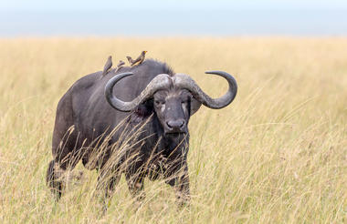
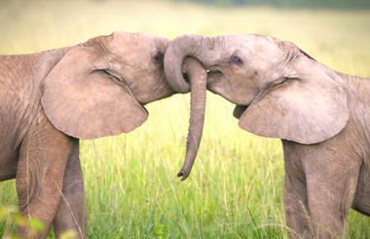
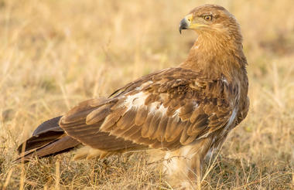
After breakfast, check out and drop off at Namanga border.

Tanzania
Day 1: Arrival in Tanzania
Meet at Namanga border and transfer to Arusha. Stay at Kibo Palace Hotel, in an Executive Room. Meals included: Bed and Breakfast.
Day 2: Arusha National Park and Walking Safari
Depart from Arusha to Arusha National Park, known for diverse fauna and flora. Explore Ngurdoto Crater, enjoy a walking safari with an armed ranger, and have a picnic lunch. Return to Kibo Palace Hotel. Meals included: Full Board.
Day 3: Arusha to Tarangire National Park
After breakfast, drive to Tarangire National Park. Enjoy game drives spotting elephants and baobab trees. Overnight at Marera Valley Lodge in Karatu. Meals included: Full Board.
Day 4: Ngorongoro - Ndutu Area
Journey to Ndutu via Ngorongoro Conservation Area. Experience a half-day game drive with picnic lunch in the Ndutu area. Overnight at Heritage Camps and Lodges or similar. Meals included: Full Board.
Day 5: Full-day Game Drives in Ndutu Serengeti
Full-day game drives in Ndutu Serengeti, with picnic lunch. Overnight at Heritage Camps and Lodge or similar. Explore the Serengeti ecosystem. Meals included: Full Board.
Day 6: Depart Ndutu to Ngorongoro Crater
Depart for Ngorongoro Crater after breakfast. Enjoy game drives and picnic lunch in the crater. Return to Karatu for overnight at Marera Valley Lodge or similar. Meals included: Full Board.
Day 7: Lake Eyasi - Hadzabe & Datoga Tribes
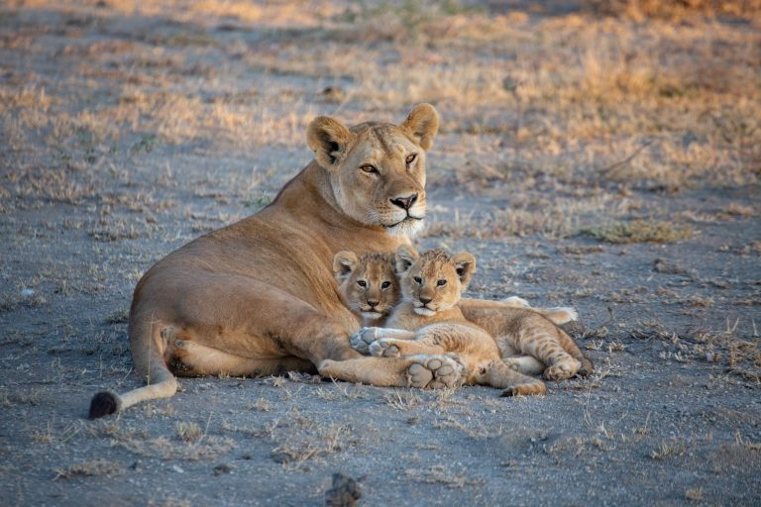
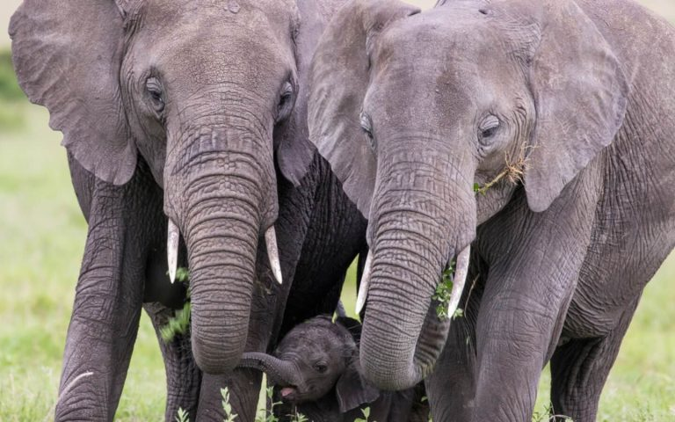
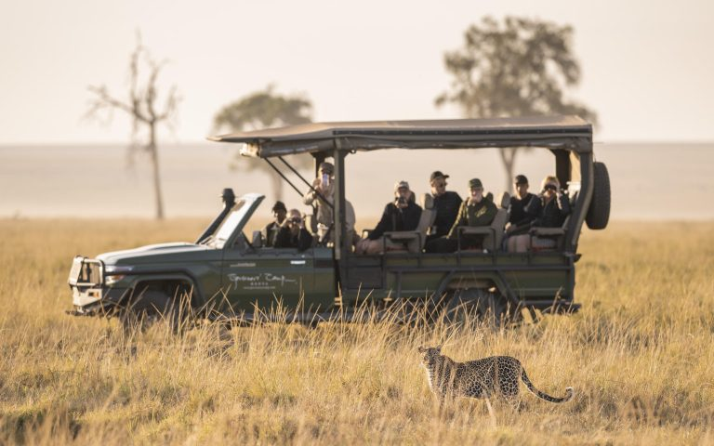
Visit Lake Eyasi for a cultural experience with Hadzabe and Datoga tribes. Enjoy a picnic lunch and return to Karatu. Accommodation at Marera Valley Lodge or similar. Meals included: Full Board.

Uganda
Day 1: Entebbe - Nile
Activities: Airport pickup at 11am, drive to Haven, optional village tour around haven. Accommodation: The Haven. Accommodation upgrade option: ($150 supplement ppp) Wildwaters Lodge. Meal plan: Lunch – sandwiches, dinner at the lodge.
Day 2: Nile – White Water Rafting
Activities: White water rafting. Accommodation: The Haven. Accommodation upgrade option: ($150 supplement ppp) Wildwaters Lodge. Meal plan: Breakfast and dinner at the lodge, lunch at the rafting site.
Day 3: Nile – Murchison Falls National Park
Activities: Drive to Murchison Falls National Park, visit the top of the falls. Accommodation: Pakuba Lodge. Accommodation upgrade option: ($90 supplement ppp) Paraa Lodge. Meal plan: Breakfast and dinner at the lodge, lunch at Masindi.
Day 4: Murchison Falls National Park
Activities: Morning game drive + afternoon boat to the bottom of the falls. Accommodation: Pakuba Lodge. Accommodation upgrade option: ($90 supplement ppp) Paraa Lodge. Meal plan: Breakfast, lunch, and dinner at the lodge.
Day 5: Murchison Falls National Park – Crater Lakes
Activities: Drive to Fort Portal/Crater Lakes, optional afternoon lake tour. Accommodation: Turaco Treetops. Accommodation upgrade option: ($150 supplement ppp) Papaya Lake Lodge. Meal plan: Breakfast and dinner at the lodge, lunch at a local restaurant.
Day 6: Crater Lakes and Kibale Forest
Activities: Morning chimpanzee tracking, afternoon lake tour. Accommodation: Turaco Treetops. Accommodation upgrade option: ($150 supplement ppp) Papaya Lake Lodge. Meal plan: Breakfast and dinner at the lodge, lunch – lunch box.
Day 7: Crater Lakes – Queen Elizabeth National Park
Activities: Drive to Queen Elizabeth National Park through Baboon Cliff, visit the salt lake, optional evening game drive. Accommodation: King Fisher Lodge. Accommodation upgrade option: ($70 supplement ppp) Mweya Lodge. Meal plan: Breakfast and dinner at the lodge, lunch - lunch box.
Day 8: Queen Elizabeth National Park – Bwindi National Park
Activities: Drive to Bwindi National Park, game drive at Ishasha (tree climbing lions). Accommodation: Due to location of the gorilla permits. Meal plan: Breakfast and dinner at the lodge, lunch – local restaurant.
Day 9: Bwindi National Park – Gorilla Tracking
Activities: Gorilla tracking. Accommodation: Due to location of the gorilla permits. Meal plan: Breakfast and dinner at the lodge, lunch – lunch box.
Day 10: Bwindi National Park – Entebbe Airport
Activities: Flight from Kehihi airstrip to Entebbe airport. Meal plan: Breakfast at the lodge, lunch according to flight time.
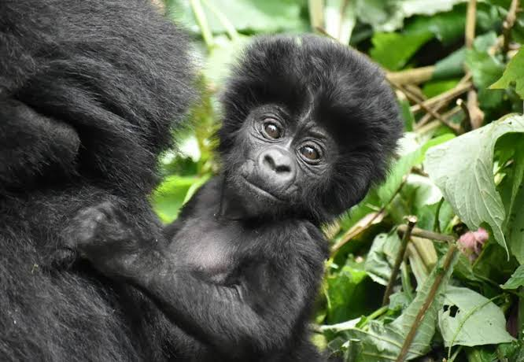
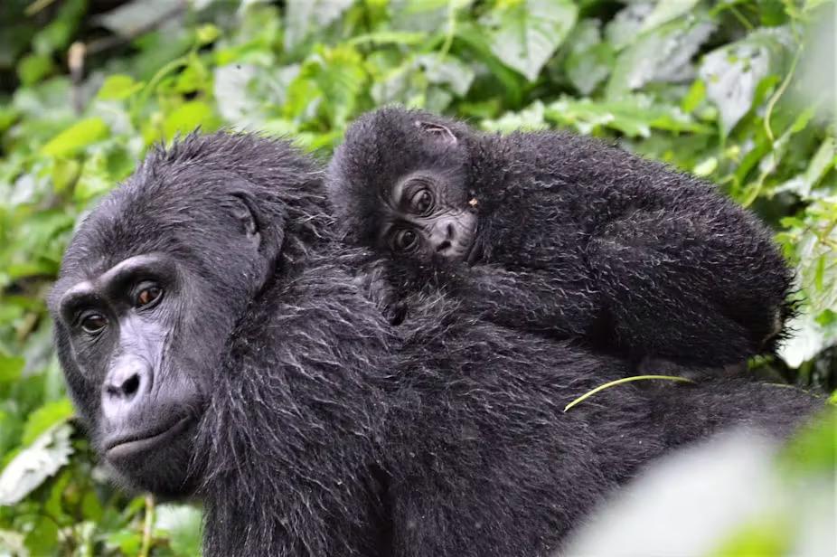

Madagascar
Day 1: Antananarivo
Arrival at the international airport of Ivato; after formalities process, meet with your driver and guide; then transfer to your hotel close to the airport; accommodation at the Relais des Plateaux (4*) or similar; overnight at hotel.
Day 2: Antananarivo > Morondava > Kirindy
Breakfast at hotel; according to your flight schedule, transfer to the national airport of Antananarivo; fly to Morondava; meet with your driver-guide at Morondava airport; lunch at a restaurant; continue your way to Kirindy and enjoy the sunset at the avenue of baobabs; transfer to your hotel; check-in at the lodge; dinner and overnight at Relais du Kirindy (2*) or similar.
Day 3: Kirindy > Morondava
Breakfast at the lodge; morning visit to Kirindy Reserve; a unique dry forest where one can find giant jumping rats; lunch at the restaurant; transfer to Morondava; on the way, visit the Baobab Amoureux; transfer to your hotel; check-in at the hotel; dinner at the restaurant; overnight at Hotel Palissandre Côte Ouest (4*) or similar.
Day 4: Morondava > Bekopaka
Breakfast at the hotel; departure to Bekopaka by 4x4; enjoy crossing the Tsiribihina River by ferry; lunch at the restaurant; continue to Bekopaka; transfer to the hotel; dinner at the restaurant; overnight at Olympe du Bemaraha (2*) or similar.
Day 5: Bekopaka > Great Tsingy Breakfast at the hotel; day visit to the great Tsingy, classified World Heritage by UNESCO; picnic lunch; return to the hotel; dinner at the restaurant; overnight at Olympe du Bemaraha (2*) or similar.
Day 6: Bekopaka > Morondava Breakfast at the hotel; departure to Morondava by 4x4; lunch at the restaurant; cross the Tsiribihina River by ferry; transfer to the hotel; check-in at the hotel; dinner at the restaurant; overnight at Hotel Palissandre Côte Ouest (4*) or similar.
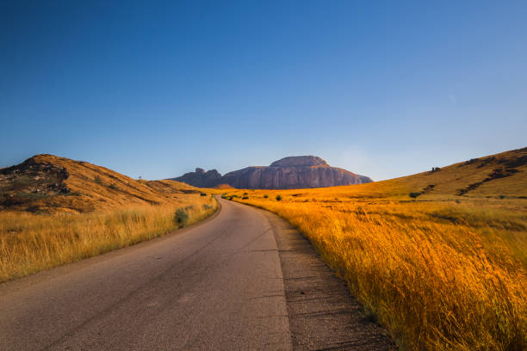
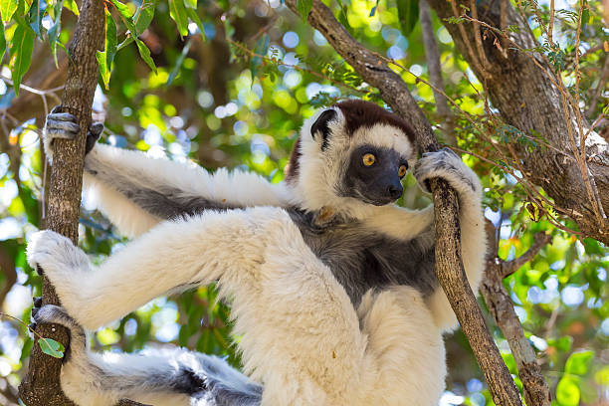
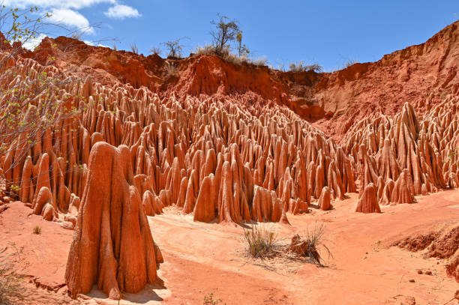
Day 7: Morondava > Antananarivo > Departure Breakfast at the hotel; transfer to the airport; fly back to Antananarivo; lunch at a restaurant; transfer to Ivato International airport for the departure flight.

South Africa
Day 1: Arrival at Victoria Falls
Upon arrival at Victoria Falls International Airport, you will be met and transferred to your hotel. The rest of the day will be spent at leisure to enjoy the facilities at the hotel. Dinner at leisure (own account).
Day 2: Victoria Falls Tour and Sunset Cruise
Breakfast at the hotel. In the morning, you will be collected from the hotel reception and enjoy a scheduled tour of the falls (Duration 2 hours). This tour is conducted in the morning. You will be accompanied through the Rainforest by one of our qualified guides who will give a brief history of the Falls themselves as well as detailing the flora, fauna, bird & wildlife, and other points of interest. At 15:00 depart on a sunset cruise on the Zambezi River. Lunch and dinner at leisure (own account).
Day 3: Optional Activities in Victoria Falls
Breakfast at the hotel. Optional excursions on offer: Wild Horizons Elephant Art: Wild Horizons and Art of Africa have teamed up to create a unique elephant experience that is brought to life by the artistic strokes of your fingertips, while surrounded by the African bush. After interacting with the “models”, guests will make their way to the adjacent waterhole and mud wallow where under the shade of an enormous Mopane tree, they will find a chair and easel - each set up with a fresh sheet of paper. Once finished, guests will enjoy a delicious two-course buffet lunch. Wild Horizons Helicopter Flight (13 min): The 13-minute scenic flight over the mighty Victoria Falls is a once-in-a-lifetime experience. The pilot will fly circuits over The Falls in both directions giving you the best viewing and photographic opportunities. Wild Horizons Gorge Swing: Leap into the wide-open air as you plunge into the mouth of the Batoka Gorge, Victoria Falls. Experience a 70m free fall before you begin swinging.
Day 4: Transfer to Chobe National Park
Breakfast at the hotel. Check out by 10:00 and transfer to Chobe. Check in at Chobe Game Lodge and relax until your first game activity in the afternoon. Dinner included at the lodge.
Accommodation: Chobe Game Lodge
Day 5: Chobe National Park
Enjoy an early morning game activity followed by breakfast. Lunch included at the lodge. Afternoon game activity followed by dinner.
Accommodation: Chobe Game Lodge
Day 6: Departure
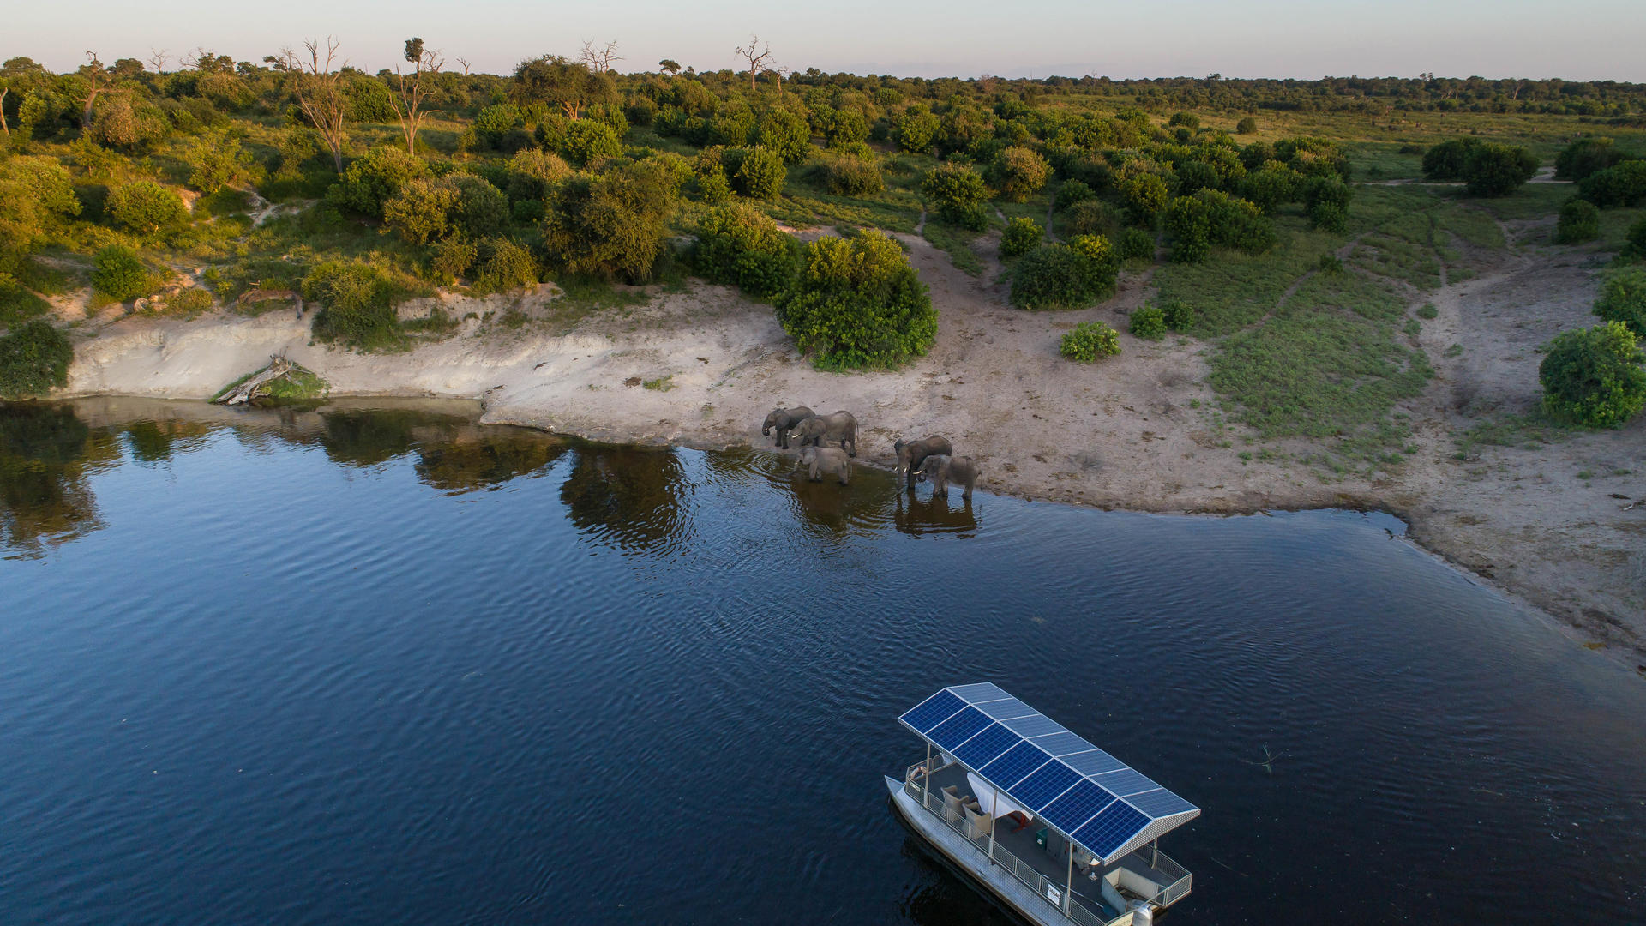
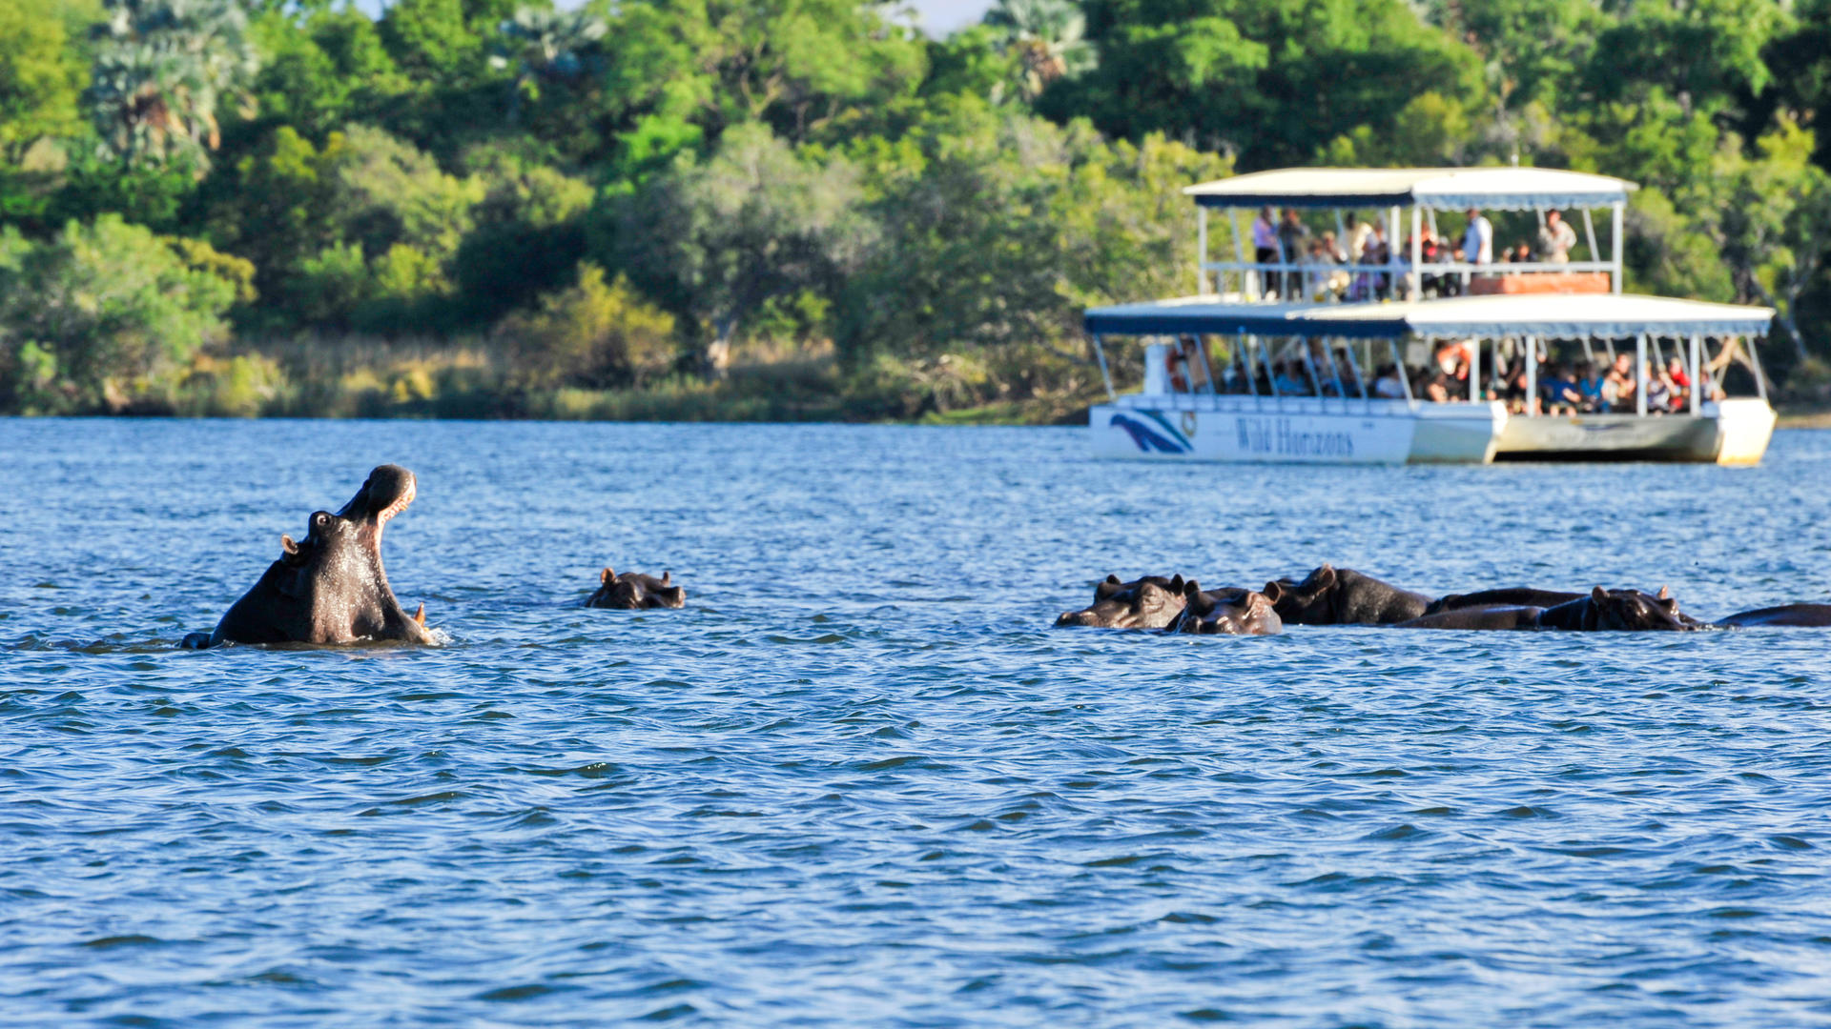
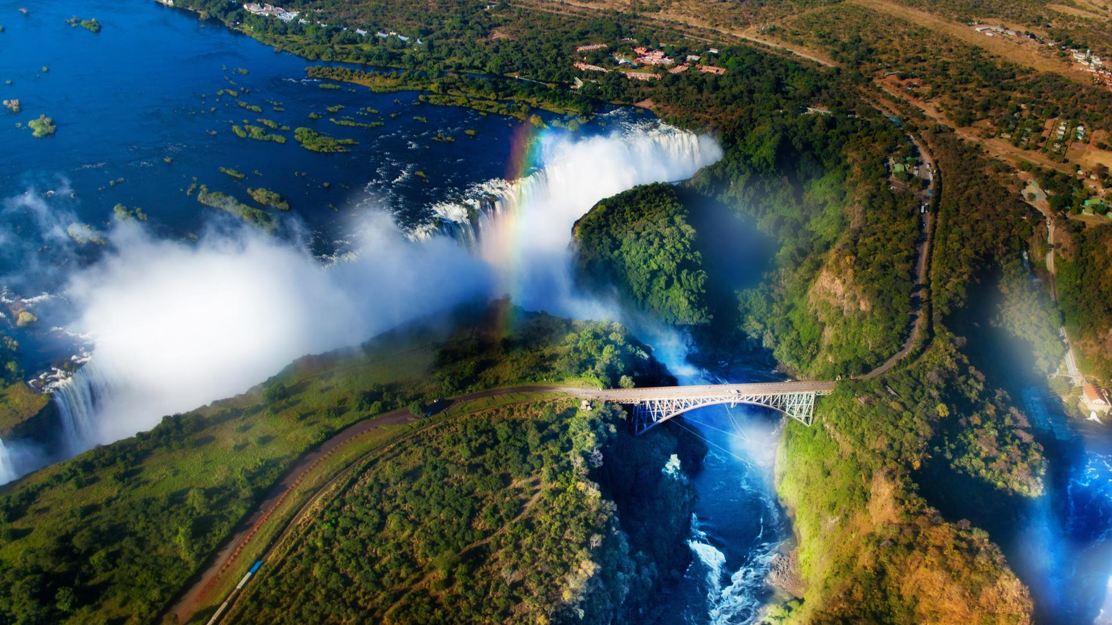
Enjoy an early morning game activity (if flight departure time allows) followed by breakfast. Scheduled road transfer to Kasane Airport.

